Name: _____________________

Exploring the Effects of the Parameters in the Following Functions:

f (x) = a (tan(bx – c)) + d
f ‘(x) = a (cot(bx – c)) + d
g (x) = a (csc(bx – c)) + d
h (x) = a (sec(bx – c)) + d

- Predict how the values of a, b, c, and d will affect the graph of the functions.

- Using the Shodor.org website
http://www.shodor.org/interactivate/activities/DataFlyer/
Type in the function f(x) = 1*tan(1*x - 0) + 0.
Change the value of a, b, c, & d and observe what happens.
Do the same for f ‘(x), g(x), & h(x)

- Describe how the values of a, b, c, and d affect the graph of the function.

- Based on your answer to #3, provide a description of how, in terms of a, b, c, and d, you can determine the amplitude, period, horizontal shift, and vertical shift of the graph.

- Graph the following by hand.

  - y = tan (2x)
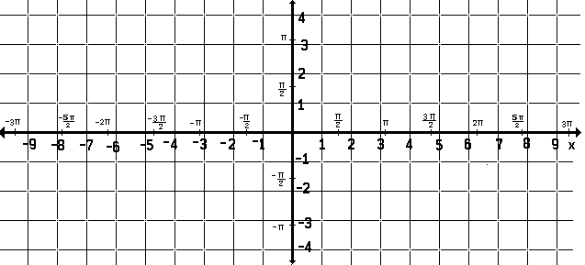

  - y = 2 cot (x) +1

  - y = ½ sec(x – (π/4))

  - y = csc(x – (π/2)) - 3

